## Question 1 (Present your answers using PowerPoint slides)

(a) Susie is a new programmer working with you in a software house. She would like to know how to use colours effectively for screen output. Give her some guidelines that might be useful to her. For each guideline, give an example (**own example**) to convince her.

(b) You have been asked to help in the development of an online Stocks System. **Table 1** below shows some of the important information that must be published on the main page i.e. the most active stocks for a particular trading day. Your software manager would like to seek your advice on how to use proper colours to enhance the usability of the Stocks System.

## Table 1: Most Active Stocks

|  |  |  |  |
| --- | --- | --- | --- |
| **Stock Code** | **Name** | **Volume** | **Changes** |
| 8200 | GENETECH | 2,500,000 | +1.60 |
| 0028 | AIR COMMUNICATION | 1,200,000 | +0.80 |
| 5303 | IRIS | 900,000 | 0.00 |
| 5088 | YXL | 80,000 | 0.00 |
| 7110 | CHEE KEE | 60,000 | -1.50 |

Required:

Demonstrate how you may apply colours to the information given in Table 1 to enhance the usability of the Stocks System. Justify the choice of colours used.

Part A answers

<https://edu.gcfglobal.org/en/beginning-graphic-design/color/1/>



The easiest formula for harmony is **monochromatic** because it only uses **one color**or**hue**. To create a monochromatic color scheme, pick a spot on the color wheel, then use your knowledge of **saturation**and**value** to create variations. The best thing about monochromatic color schemes is that they're **guaranteed to match**. The colors suit each other perfectly because they're all from the same family.

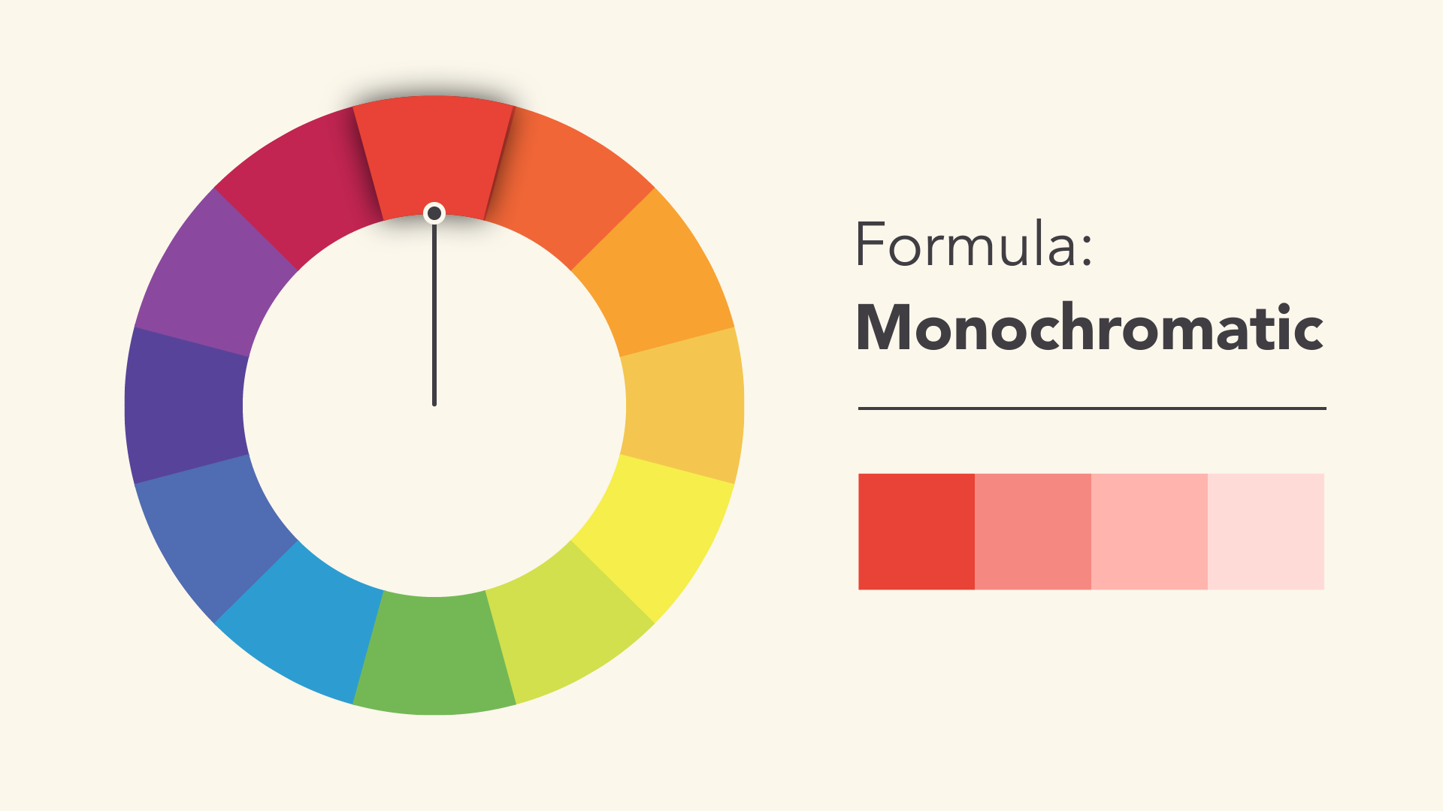

An **analogous** color scheme uses colors that are **next to each other** on the wheel, like reds and oranges or blues and greens.

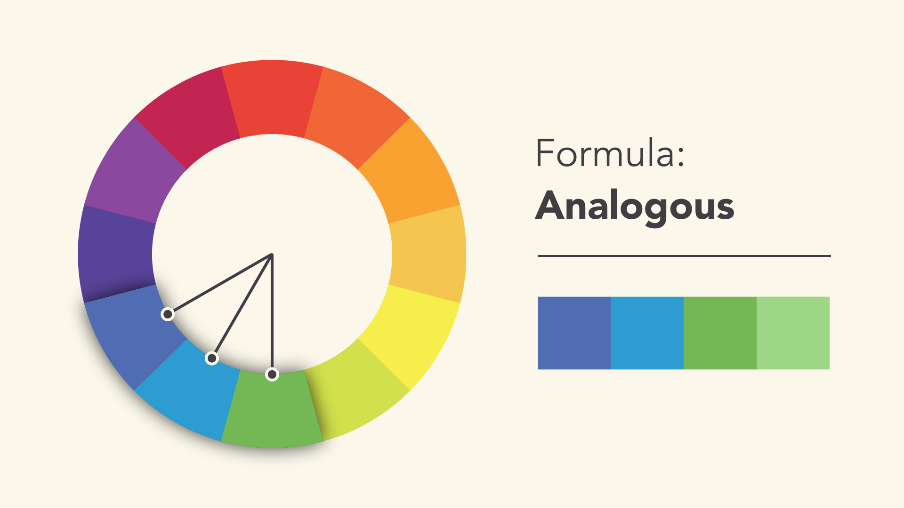

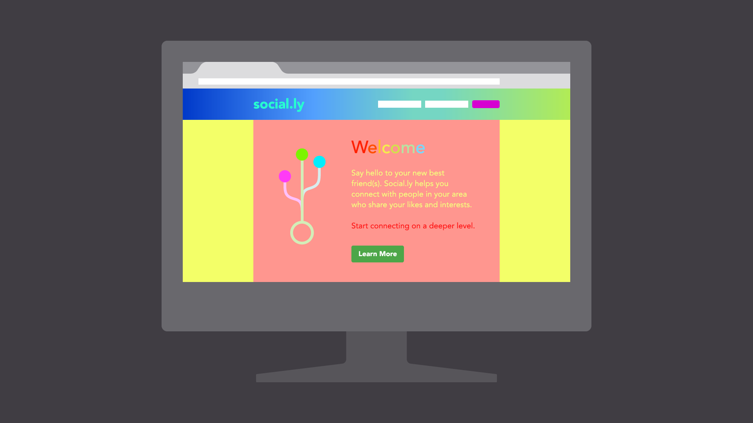

Over use of colors

Neutral colors like black, white, and gray can help you **balance** your design, so when you do use color, it really stands out.



For example, **bright colors** tend to have a fun or modern vibe



**Desaturated** colors often appear more serious or businesslike.



Part b answers

## Table 1: Most Active Stocks

|  |  |  |  |
| --- | --- | --- | --- |
| **Stock Code** | **Name** | **Volume** | **Changes** |
| 8200 | GENETECH | 2,500,000 | +1.60 |
| 0028 | AIR COMMUNICATION | 1,200,000 | +0.80 |
| 5303 | IRIS | 900,000 | 0.00 |
| 5088 | YXL | 80,000 | 0.00 |
| 7110 | CHEE KEE | 60,000 | -1.50 |

Changes (+) – Green, Changes (0) – Black, Changes (-) – Red

## Question 2 (Present your answers using PowerPoint slides)

1. Find any 5 artefacts *(e.g. signboard, signage, announcement on noticeboard, etc*) in your campus. Take picture of the artefacts and insert them into PPT slides. Analyse the color(s) used and based on what you have learned in HCI, comment whether the color(s) used is good or poor. Give reasons to support your answer.

|  |  |  |
| --- | --- | --- |
| **Item** | **Color of the item**  **(at present)** | **Suggestion for the change of color (if appropriate)** |
| Examination authorisation slip | White | Yellow |
| Exam question paper | Pink color | Blue |
| Answer booklet | green | Blue |
| Attendance slip | White | Yellow |
| Table surface |  | Grey – Neutral colour |
| String that we used to tied the answer booklet |  | White |

1. Explain what *closure* means.

The informative feedback at the completion of a group of actions gives the operators or users the satisfaction of accomplishment, a sense of relief, and an indication that the way is clear to prepare for the next group of actions or the task has been completed by the operators/users.

For example , When a purchase process is finished, remember to display a “Thank you” message. Let the user know that he/she has done all that’s needed, the purchase order is now in the system and he/she can navigate elsewhere on the site with ease of mind.

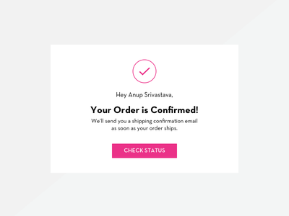 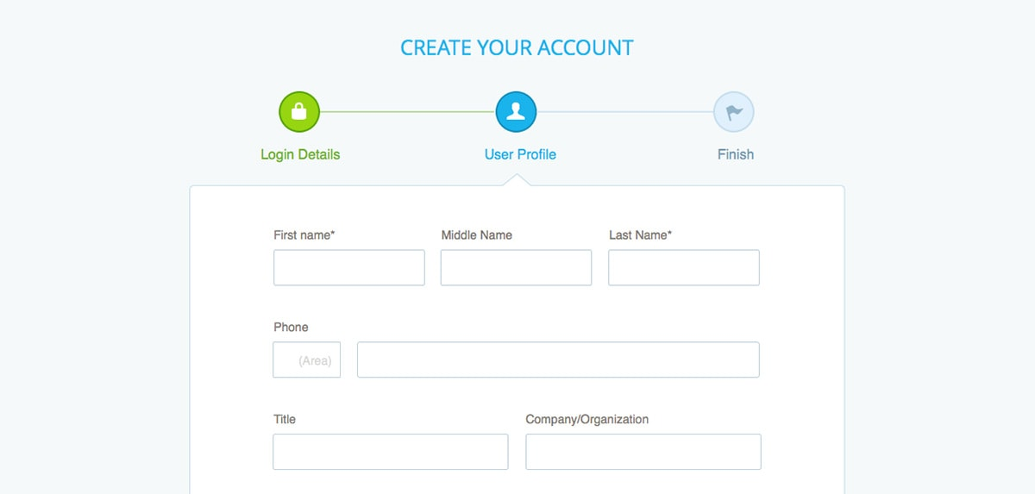

1. *“Closure requires feedback”****.*** Do you agree with the above statement? Explain your answer by using one suitable example (***own example***). In addition, discuss the consequences where there is little or no feedback provided.

**Yes**

We need to provide a closure because it is the informative feedback at the completion of a group of actions gives the operators or users the satisfaction of accomplishment, a sense of relief, and an indication that the way is clear to prepare for the next group of actions or the task has been completed by the operators/users. For example , When a purchase process is finished, remember to display a “Thank you” message. Let the user know that he/she has done all that’s needed, the purchase order is now in the system and he/she can navigate elsewhere on the site with ease of mind.

If we don’t provide the closure feedback to the user, the user may not know whether he or she has completed the required task or not such as ordering an items, the users may submit the same order twice or the order has not been submitted yet but the user thought already submitted the orders.





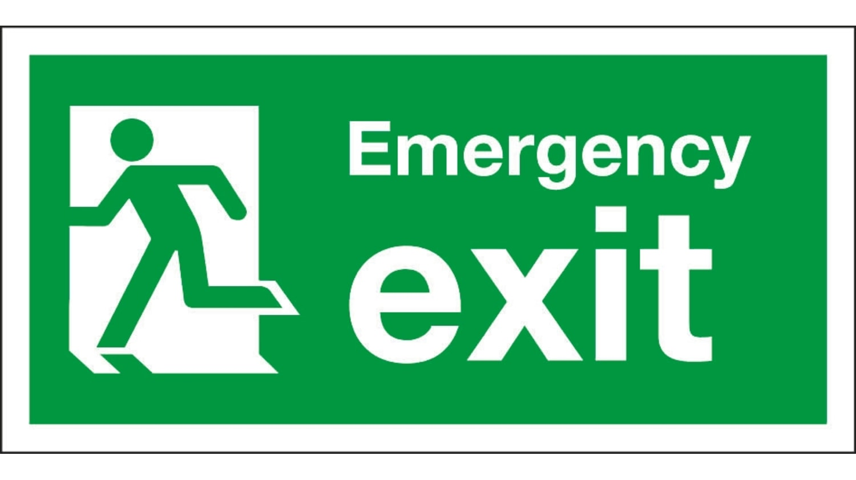

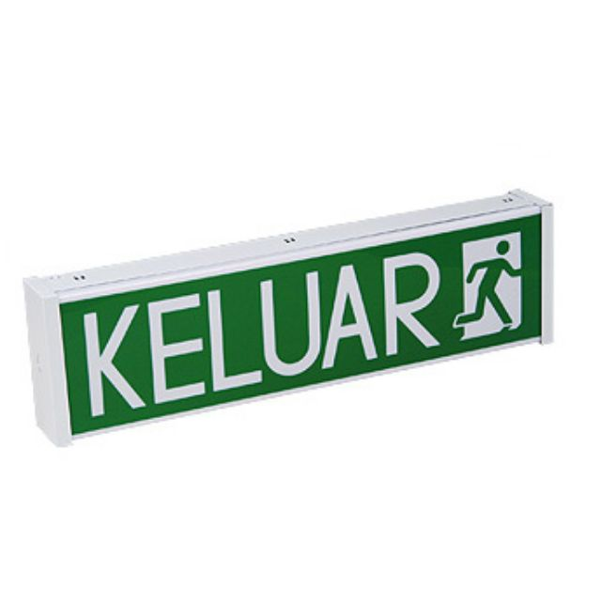

Foreigner who don’t understand Malay languages, prefer to use more than one language

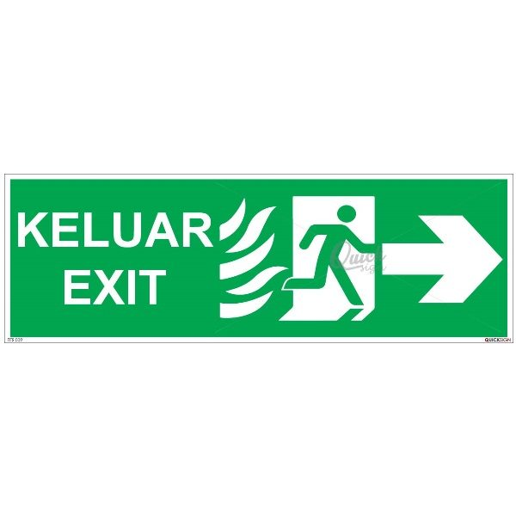



**Question 3** *(Present your answers using PowerPoint slides)*

According to Nielsen (2001), good error messages are *Explicit, Human Readable, Polite, Precise* and *Constructive.*

(a) Give 2 examples (**own examples**) of error messages that conform to some or all of above characteristics. State the source of your answers.

(b) Differentiate between a mistake and a slip. Give an example (**own example**) of each. Suggest how both (mistake and slip) can be avoided.

* 1. “Please enter an account name that is at least 3 characters long and uses only a-z, A-Z, or 0-9 characters.” – store.steampowered.com/join

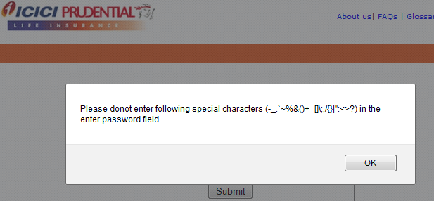

Visible and readable: uses simple words

Polite: uses please.

Precise: Tell exactly what is the problem.

Constructive: Suggest user on how to proceed.

“Stupid, complete the form first before you submit !” – eforum6.cari.com/register

Not polite and constructive, bad error message use ! symbols.

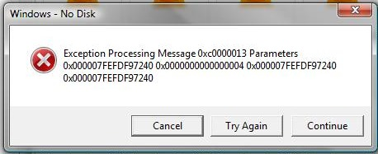

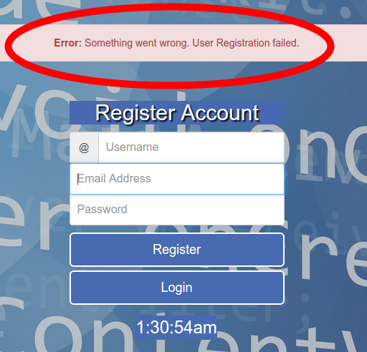

* 1. Mistake: An incorrect action taken based on an incorrect decision made by the user. Eg. Delete the whole folder of an installed program in a computer as an uninstall program action, they thought this is the way to removed the program.

Slip: An error happened by unintentional action. Eg. Accidentally click the “like” button on facebook.

Solution :

Slip – better interface design

* **Provide adequate separation** between elements to be selected.
* Minimize typing by using menus
* Provide clear feedback on the system’s current state

Mistake – better understanding of system.